Print Form Email Form
64th ANNUAL OMFPOA TRAINING & EDUCATIONAL SYMPOSIUM

HOSTED BY THE LONDON FIRE DEPARTMENT
“Bringing It Back to London”
Register by, April 8 2022
SAVE!!
Early Bird Rate is $460.00
June 5th - 9th, 2022
Delta London Armouries
325 Dundas St, London, ON, N6B 1T9

REGISTRATION FORM

Name: |  | Organization:
Address: |  | City:
Phone: |  | Email:
Make your reservation at the Delta London Armouries today! Call toll free 1 800-668-9999 or click here to book online! Room rates are $149.00 plus $16.95/night self-parking and use of amenities. Use the group code ON Municipal Fire Prevention.
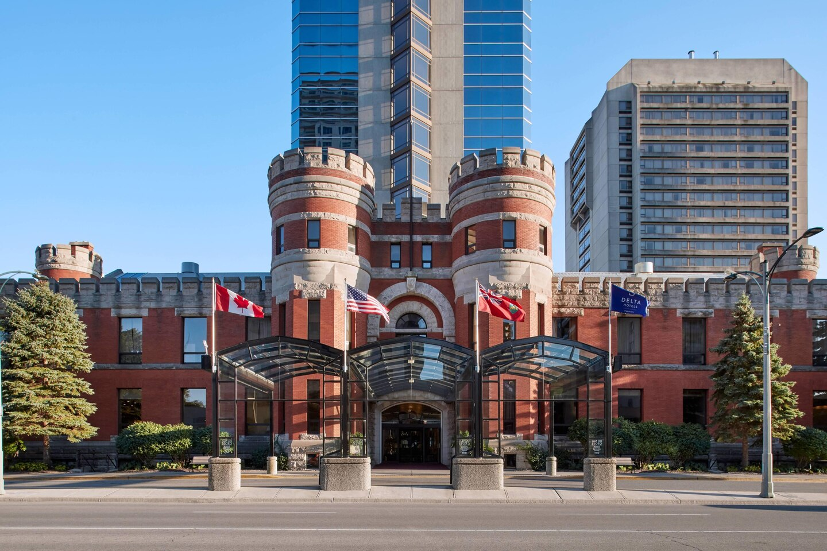
Book by May 6, 2022, to guarantee your room. PROOF OF COVID-19 VACCINATION MAY APPLY Enter Quantity
Full Registration:  Delegate package, all sessions, coffee breaks, breakfasts, lunches, Monday dinner at Union 10 Distillery, Tuesday trade show food, Gala Dinner and Tours | OMFPOA Members Early-Bird price | $460.00
 | OMFPOA Members price - after April 8, 2022 | $510.00
 | Non-Members of the OMFPOA | $560.00
Daily Registration:  Includes: All sessions that day, all day coffee breaks and lunch. Registration starts at 7:30 am each morning.  *** Gala Dinner, Monday Night entertainment and Trade Show not included *** | Monday (day registration) | $125.00
 | Tuesday (day registration) | $125.00
 | Wednesday (day registration) | $125.00
 | Thursday (day registration) | $75.00
Please mail printed registrations to:  Tracy McLeish  Fire Prevention Division  London Fire Department  400 Horton Street East  London, ON N6B 1L7  Cheques made payable to: Treasurer City of London  *** Cheques not made payable to Treasurer City of London will be returned ***  Visa/Mastercard – Please complete the attached form.  Email: tmcleish@london.ca or Fax: 519-661-8419 | Gala Dinner:  For all registrants. Business casual or Dress uniform.  (Enter quantity of dinners)  Beef Dinner _____ Chicken Dinner _____  Dietary Restrictions ________________________ | $65.00
 | Monday Night Entertainment - additional tickets | $25.00
 | Trade Show - additional tickets | $25.00
 | TOTAL:

Y you...

