2021
Training and Education Program

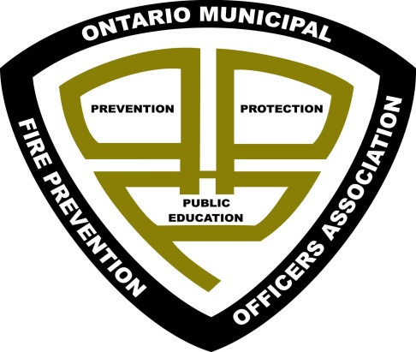

Ontario Municipal Fire Prevention Officers Association
OMFPOA

MISSION
To co-ordinate efforts of its members in the fields of Fire Prevention, Fire Safety, Public Education, and Fire Protection, and by doing, endeavour to provide more efficient, effective, and uniform Fire Prevention Programs in Ontario.

PREFACE

Training and ongoing professional development is being offered on a monthly basis by utilizing virtual platforms. These training sessions will be live, recorded and posted in the members’ only section of the OMFPOA website.

Below you will find the dates, times and agendas for the monthly training sessions that have been developed and scheduled. Due to the nature of our current global situation, there may be last minute changes that are beyond our control. We will however strive to ensure the training sessions continue and that the agendas stay as close as possible to the original intent.

Each month’s agenda will be posted on the website and will be located in the Training section and on the Calendar.

Thank you everyone for your ongoing support, patience, and assistance. We are looking forward to reconnecting with the members on a monthly basis, even if it is in a virtual format.

Stay safe, stay healthy!

OMFPOA Executive Members

January 28, 2021

TIME | TOPIC | Speaker
9:00 am – 9:30 am | Opening comments | OMFPOA President
9:30 am – 9:50 am | NFPA Canada Pub Education Update | Laura King  Public Education Representative Canada
9:50 am – 10:20 am | OAFC Fire Prevention & Public Education Committee Update | Windsor Fire  Deputy Fire Chief Andrea Dejong
10:20 – 10:30 am | BREAK
10:30 – 11:00 am | Ontario Fire College Update | Guy Degagné  ADFM/Principal  OFMEM
11:00 – 11:30 am | OFMEM Public Education | Aman Kainth  Manager of Public Education and Communications OFMEM
11:30 – 11:45 am | Round Table / Networking | OMFPOA Executive Director
11:45 - 12:00 pm | Draws and closing statement. | OMFPOA Executive Director

February 25, 2021

TIME | TOPIC | Speaker
9:00 am – 9:15 am | Opening comments | OMFPOA President
9:15 am – 11:00 am | CAN-ULC for AHJ’s | TBD
11:00 – 11:15 am | Draws and closing statement. | OMFPOA Executive Director

March 25, 2021

TIME | TOPIC | Speaker
9:00 am – 9:15 am | Opening comments | OMFPOA President
9:15 am – 10:00 am | NFPA 921 Update | Robert (Bob) Duval  NFPA’s Northeastern Regional Director
10:00 am – 11:00 am | Electrical Safety Authority  Update, Orders, Safety Concerns | Said Ismail  Senior Planner/Safety Specialist, Analytics
11:00 – 11:30 am | Round Table / Networking | OMFPOA Executive Director
11:30 – 11:45 am | Draws and closing statements. | OMFPOA Executive Director

April 22, 2021

TIME | TOPIC | Speaker
9:00 am – 0915 am | Opening comments | OMFPOA President
9:15 am – 10:30 am | Emergency Preparedness Programming | OFMEM  Aman Kainth
10:30 am – 11:00 am | Mental Health in today’s pandemic | Michelle Pharand  Pathstone Mental Health
11:00 – 11:30 am | Round Table / Networking | OMFPOA Executive Director
11:30 – 11:45 am | Draws and closing statement. | OMFPOA Executive Director

May 27, 2021

TIME | TOPIC | Speaker
9:00 am – 0910 am | Opening comments  Nominations for Executive Positions. | OMFPOA President
9:00 am – 10:00 | Case Study -  Combustible materials in access to exits.  Appealed Inspection Order. | Ottawa Fire Service  Division Chief Gwen Lewis
10:00 am – 10:15 am | Fire Service initiative  Prevention, Public Education, Investigation | Fire Service TBD
10:15 am – 10:30 am | Fire Service initiative  Prevention, Public Education, Investigation | Fire Service TBD
10:30 am – 10:45 am | Fire Service initiative  Prevention, Public Education, Investigation | Fire Service TBD
10:45 am – 11:00 am | Fire Service initiative  Prevention, Public Education, Investigation | Fire Service TBD
11:00 am – 11:15 am | Fire Service initiative  Prevention, Public Education, Investigation | Fire Service TBD
11:15 am – 11:30 am | Fire Service initiative  Prevention, Public Education, Investigation | Fire Service TBD
11:00 – 11:30 am | Round Table / Networking | OMFPOA Executive Director
11:30 am – 12:00 pm | Draws and closing statement. | OMFPOA Executive Director

June 24, 2021 – Annual General Meeting and Elections

TIME | TOPIC | Speaker
9:00 am – 9:15 am | Opening comments | OMFPOA President
9:15 am – 9:30 am | Review of Nominees. | TBD
9:30 am – 10:45 am | Annual General Meeting | Host Executive Director
10:45 – 11:00 am | Elections for Executive Members | TBD
11:00 am – 12:00 pm | Motivational Speaker | TBD
12:00 – 12:15 am | Round Table / Networking | OMFPOA Executive Director
12:15 pm – 12:30 pm | Draws and closing statement. | OMFPOA Executive Director

Future Training Session:

July – No Training

August – No Training

September 23, 2021

October 28, 2021
November 25, 2021

December 8, 2021

