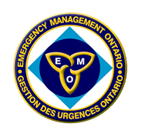
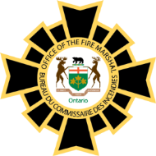
Office of the Fire Marshal and Emergency Management
2014 Public Fire Safety Education Workshops
Participant Registration Form
The 2014 Fire and Life Safety Educators’ Workshops are intended for members of the fire service who are involved in direct oversight or delivery of public fire safety education. There is no registration fee for these workshops. A separate registration form must be completed for each participant. As space may be limited, fire departments are asked to register a maximum of two (2) participants.
Please select the Public Fire Safety Education Workshop you plan to attend: |  |  | X
REGION | LOCATION | DATES
Southwest | Park Avenue Business Centre  25 Creek Road, CHATHAM, ON | 15 – 16 October, 2014
 |  | Registration Deadline: 24 September
Southeast | Portsmouth Olympic Harbour  53 Yonge Street, KINGSTON, ON | 22 – 23 October, 2014
 |  | Registration Deadline: 1 October
Central | Toronto Fire & EMS Training Centre  895 Eastern Avenue, TORONTO, ON | 28 – 29 October, 2014
 |  | Registration Deadline: 7 October
Northwest | Protective Emergency Services Training Centre  750 Hammond Avenue, THUNDER BAY, ON | 14 – 15 November, 2014
 |  | Registration Deadline: 24 October
Northeast | Lionel E. Lalonde Centre  239 Montee Principale, AZILDA, ON | 19 – 20 November, 2014
 |  | Registration Deadline: 29 October

Registrant Information
First Name: | Last Name: |  | Title/Position:
Fire Department Name:

Email address: |  | Phone Number:

EMAIL or FAX completed form to:
Gina Pontikas
Email: Gina.Pontikas@ontario.ca
FAX: 416-325-3162
PLEASE NOTE!! Registered participants will receive email confirmation with additional details regarding their workshop.

