
CAFI South Central Ontario
Chapter 006
Spring Two Day Seminar
Wednesday April 5 and Thursday April 6, 2017

Advanced Fire Dynamics, Arc Mapping, Burn Cell Investigation

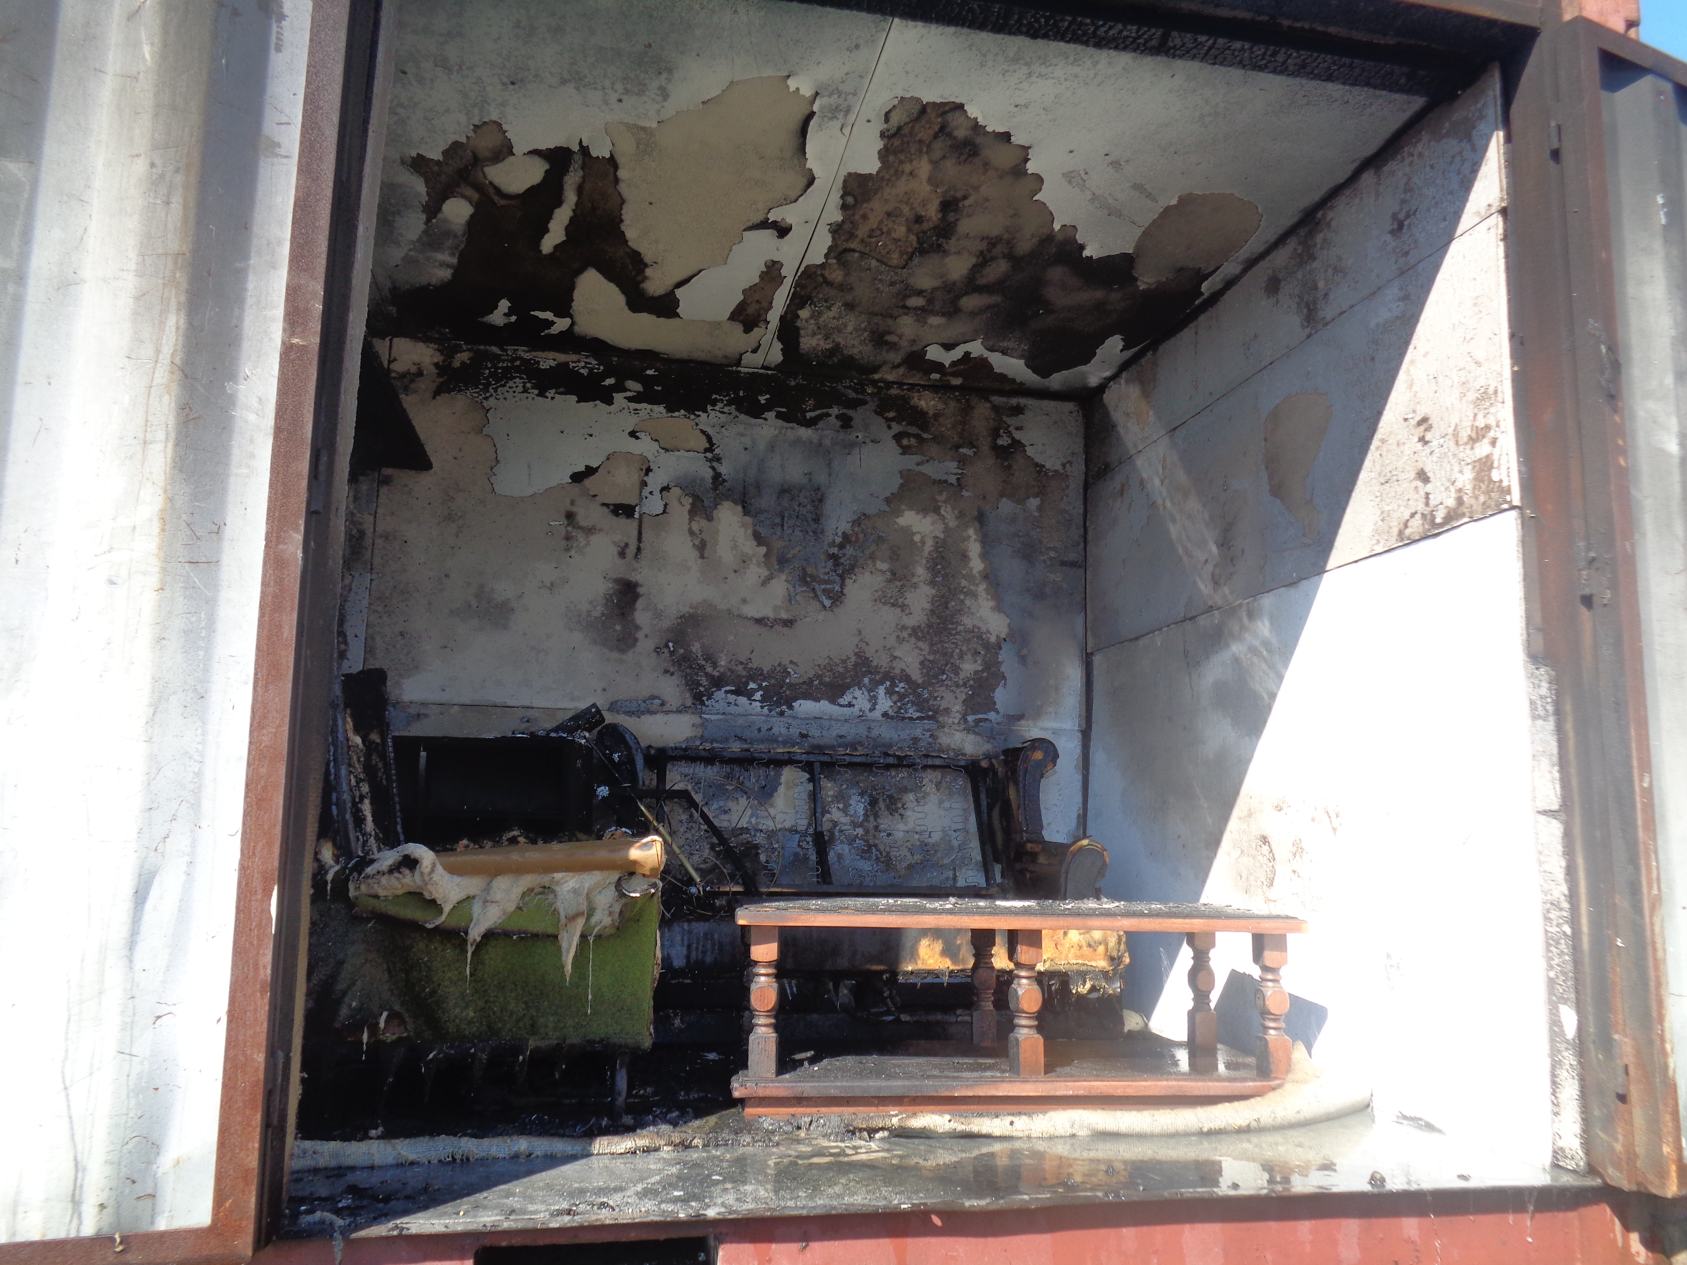
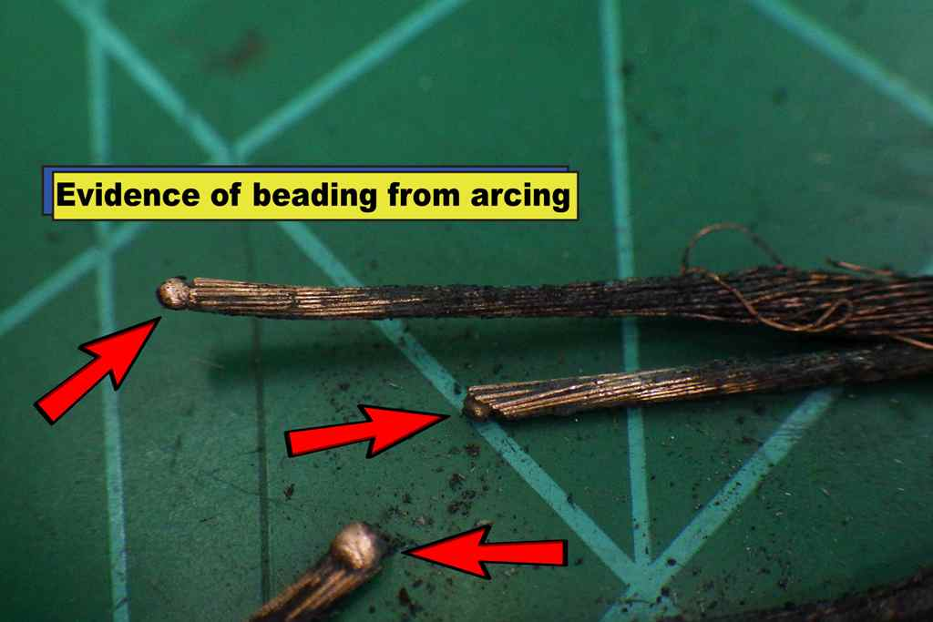

A portion of this seminar will include the viewing of a burn cell. Participants are advised to dress in fire investigation clothing and for weather conditions. Safety equipment including hard hat, safety shoes, and safety glasses will be required to be worn during the viewing.

Where: Greater Toronto Airports Authority
Fire and Emergency Services Training Institute
2025 Courtney Park Drive East, Toronto, Ontario. L5P 1B2
Guest Speaker: Jeff Minten, OFMEM

When: Wednesday April 5 – Thursday April 6, 2017

Registration - 8:00 am on Wednesday April 5

Presentations - 8:45 am to 4:00 pm (lunch included both days)

Cost: Early Registration: CAFI Members - $400 / Non-CAFI Members* - $500

After March 15th CAFI Members - $500 / Non-CAFI Members* - $600

* (Non Member Fee Includes Annual Membership)

Please Complete: (Print clearly)
Company:
Name:
 |  | First |  |  |  |  |  |  |  |  |  |  |  |  |  |  |  | Last
Address:
 | Street
 | City |  |  |  |  |  |  |  |  |  |  |  |  |  | Prov. /State |  |  |  |  |  |  |  |  |  |  |  |  |  | Postal Code
Phone No:
E-mail Address:
CAFI Members: |  |  |  | $ |  |  | X | = | $ |  |  |  |  |  |  |  |  |  |  | Membership #
Non CAFI Members: |  |  |  |  | $ |  |  | X |  | = |  |  | $ |  |  |  |  |  |  |  |  | Total: |  | $
Credit Card Payment: |  |  |  |  | Card # |  |  |  |  |  |  |  |  |  |  |  |  |  |  |  |  |  | Exp Date:
Name on Card: |  |  |  |  |  |  |  |  |  |  |  |  |  |  |  |  |  | Signature:
Email: cafi_006@rogers.com
Fax: 1- 905-623-4840
CAFI Chapter 006 Attention: Bill Reid

Send Registration Form and Payment to:

Canadian Association of Fire Investigators
1207 Bramblewood Court
Pickering, ON. L1X 1B1

Email to cafichapter006@gmail.com

Make Cheques Payable To: CAFI Chapter 006

Hotel Information

Four Points by Sheraton Toronto / Mississauga
6090 Dixie Road, Mississauga.
905-670-0050

Ask for CAFI room rate - $129/night
Price available until March 15th

By completing and submitting this form, you give consent to CAFI to collect your personal information in order to communicate with you, process your registration and make any necessary payment or other arrangements with third party service providers pertaining to your registration. CAFI’s use of personal information is described in their privacy policy posted on the CAFI website: www.cafi.ca

